

**LICENSE PLATE RECOGNITION**

**Report 3 – Data Collection**

– Hanoi, May 2021 –

**Table of Contents**

III. Data Collection 3

1. Methodology 3

2. Data description 3

3. Data Exploration 3

# III. Data Collection

## Methodology

The data used for plate detection was collected from the basement parking area, a small number are from video taken from the FPT university parking lot. We take the picture which has the plate from the video stream, reshape it to 300* 400, then label the coordinates of the 4 corners of the license plate in those pictures for each.

The data for OCR is reused from MiAI, Github, Kaggle.

## Data Description

* Plate detection:
  + There are tatal 1993 pictures containing the single license plate.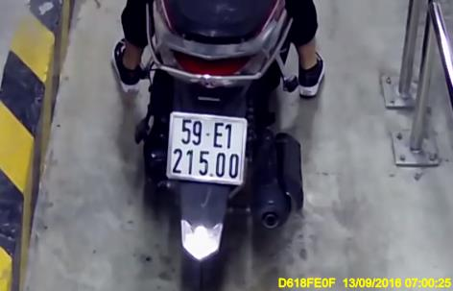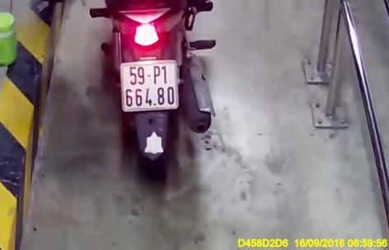
* There are 29 pictures containing multi license plates.
* We use about 80% data for training and 20% for testing.

- ORC data:

- The data are separated with a unique label. There are 38679 pictures. We use 90% data for training and 10% for testing.

## Data Exploration